**Project 2 Proposal**

Karman, Khaled

Zhang, Shirely

Iudina, Olga

Maali, Ali

Kwynn, Madison

#Metoo, #Blacklivesmatter, #LGBTQ, are all movements gaining momentum and support, while left in the dust are groups such as foster children. There isn’t a systematic way to check on the 400,000 foster children currently in foster homes, thus minuscule data document their journey. Studies have shown door-to-door checkups do not work and the foster system is described as “broken”. Children advocates are struggling to keep them from being abused and neglected. This project aims to solve the problem by giving foster children a way to blog their experiences and giving foster care administers an analytical, graphical profile of the children. Every home they move into and every time their case exchanges hands, their story will not be forgotten.

Foster handlers can review the child’s progression after logging in and using the child’s ID. Filter buttons are instilled to hone in on d3 generated graphs using data from mySQL. This process allows foster children to have life paths that are well-documented, so new foster handlers will understand them closely and can pair them with the right home. It is also a discrete way for them to report abuse especially when they do not have parents to speak for them.

Mock data will be used because the time constraint give us little time to ask permission from foster children to utilize their stories. We will be creating fictitious story lines to demo how the D3 graphs would display it. If the admin hovers over a point in the graph, the date, emotion rank, and blog will appear.

1st Child: Physical abuse/gets rehome/Successful foster family

2nd Child: Sexual abuse/gets rehome/Successful foster family

3rd Child: Gets bullied in school/Admin tells Foster Parents/Foster parents moves child to new school

4th Child: Gets bullied by other children in the family/ gets rehome/Successful foster family

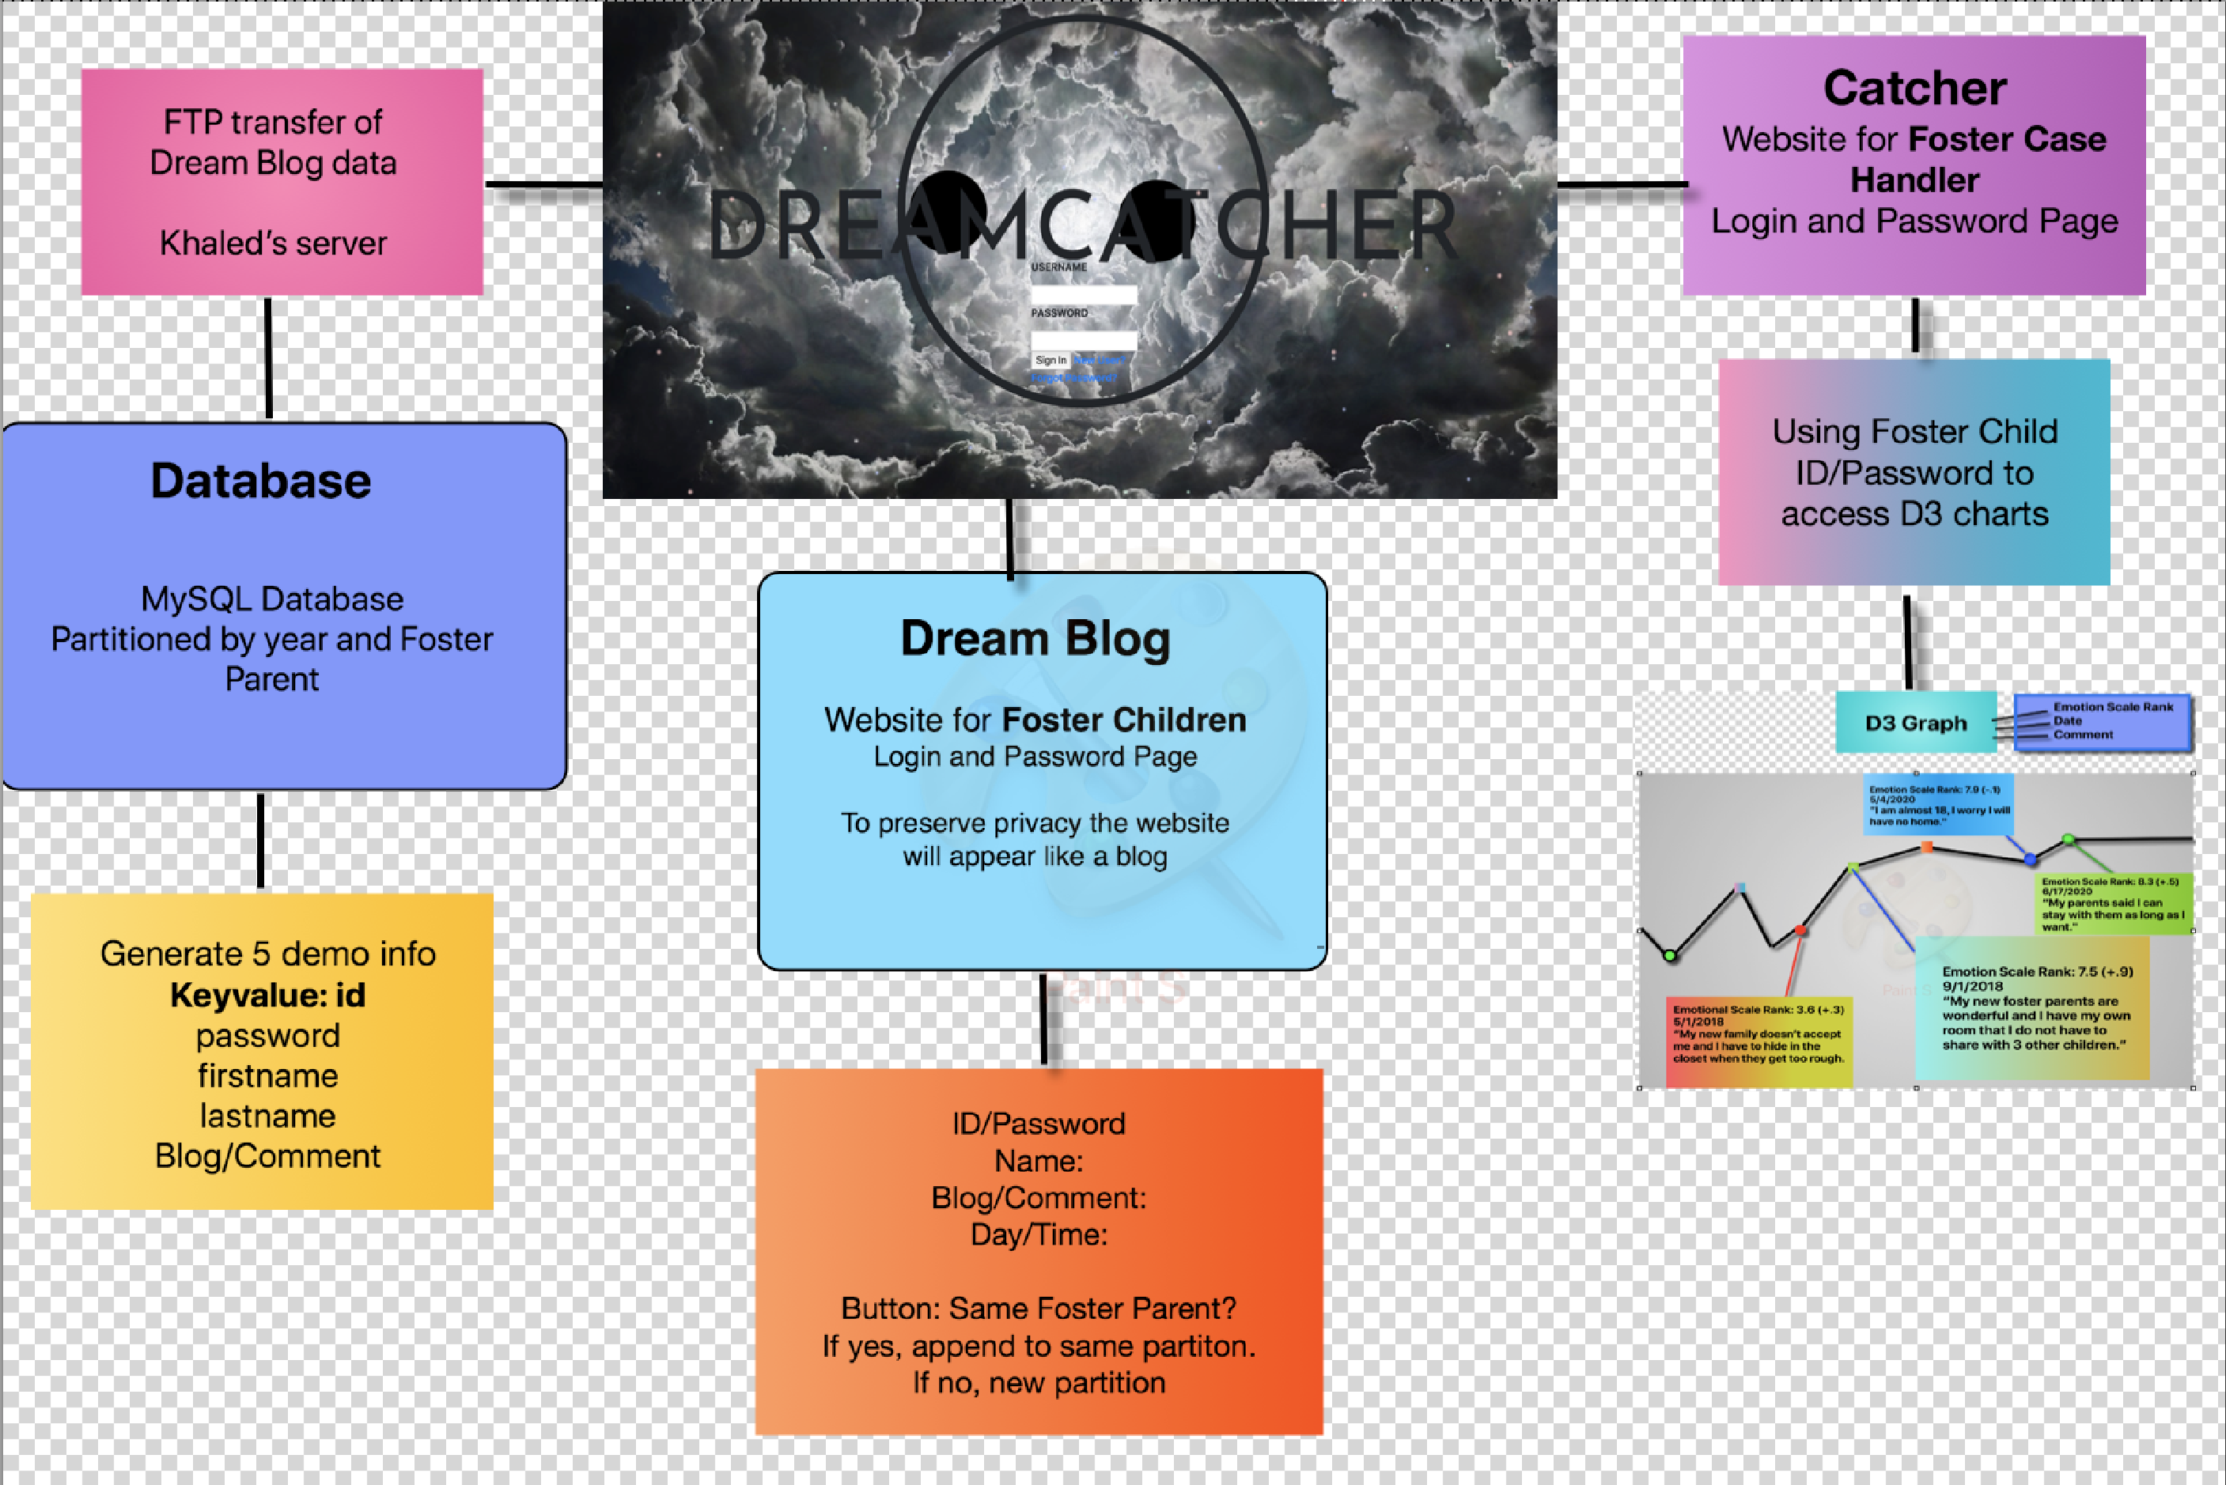  
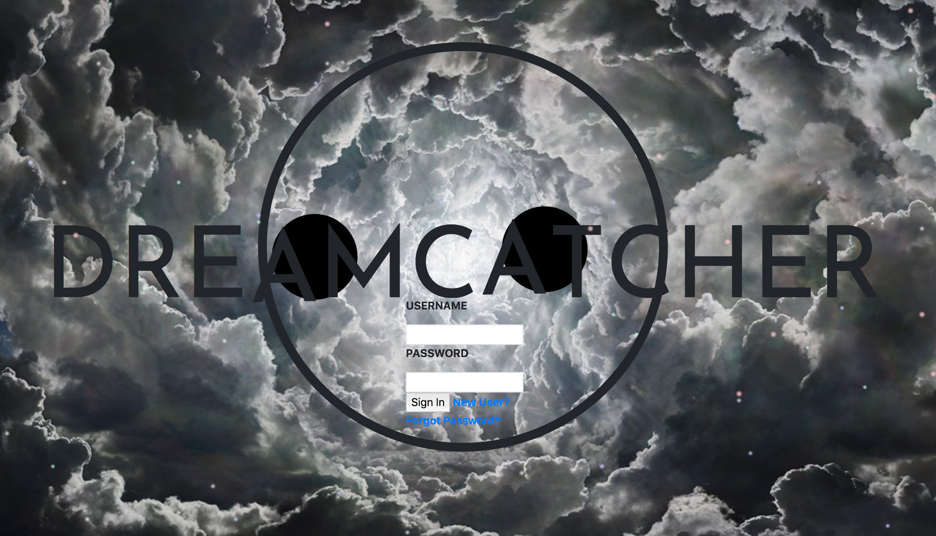

Animated Login Page in Catcher Folder

